**Software Projects Research Document**

|  |  |  |  |
| --- | --- | --- | --- |
| **Assignment Tasks:** | **Assigned to:** | **Deadline** | **Progress** |
| 1. Group Report: Project Proposal | **All** | 15/12/2017 |  |
| 1. Group Presentation | **All** | 09/03/2018 |  |
| 1. Group Final Report and Implementation | **All** | 23/03/2018 |  |

**Weekly Tasks:**

***(Please see the weekly tasks and insert your research below the table, please can you include any references you use as we will need to make a bibliography for the report VIP)***

**Week 2: The User Journey and User Involvement in the Project**

|  |  |  |
| --- | --- | --- |
| **Task:** | **Requirements:** | **Date due** |
| 1. Introduction | A short synopsis outlining the business, who we are targeting and why we are targeting those consumers. | 17 October 2017 |
| 1. Market Research / Competition | Market research on tutor figures, pricing of tutors, look at old tutoring models to see how they worked. | 17 October 2017 |
| 1. Technical Requirements | What are the technical requirements needed in order to implement the idea. | 17 October 2017 |
| 1. Investment /Sustainability | How will the project be financed (charitable status, sponsorship from supermarkets etc.) | 17 October 2017 |
| 1. Pros / Cons | What are the pros and cons | 17 October 2017 |

**Brainstorming of potential projects:**

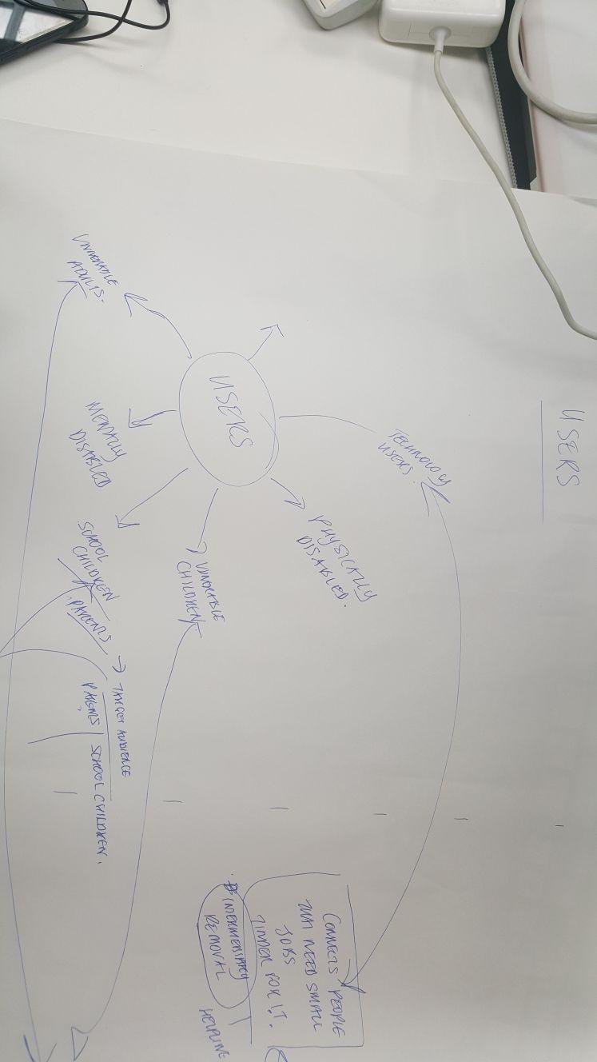

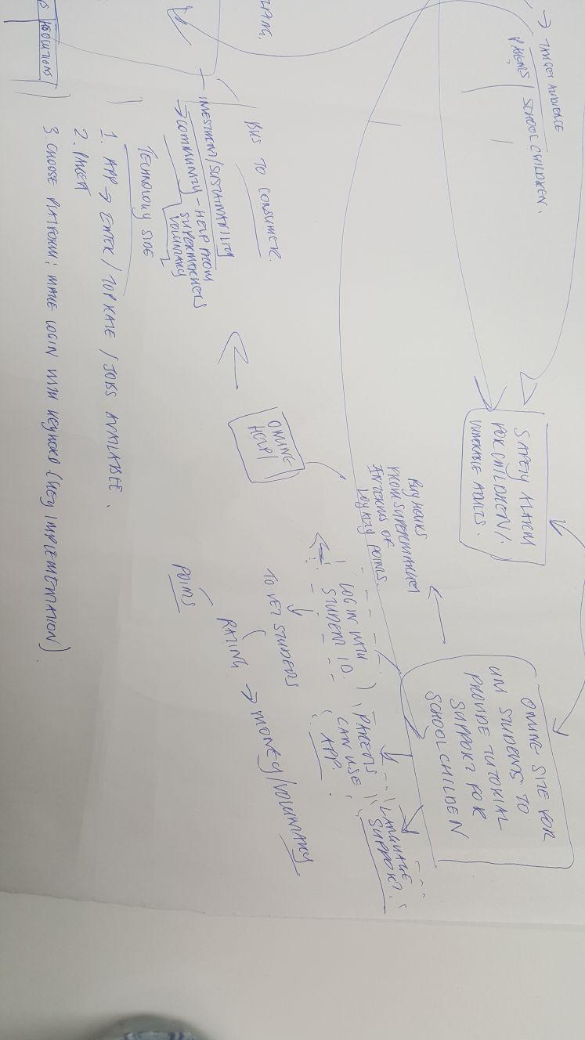

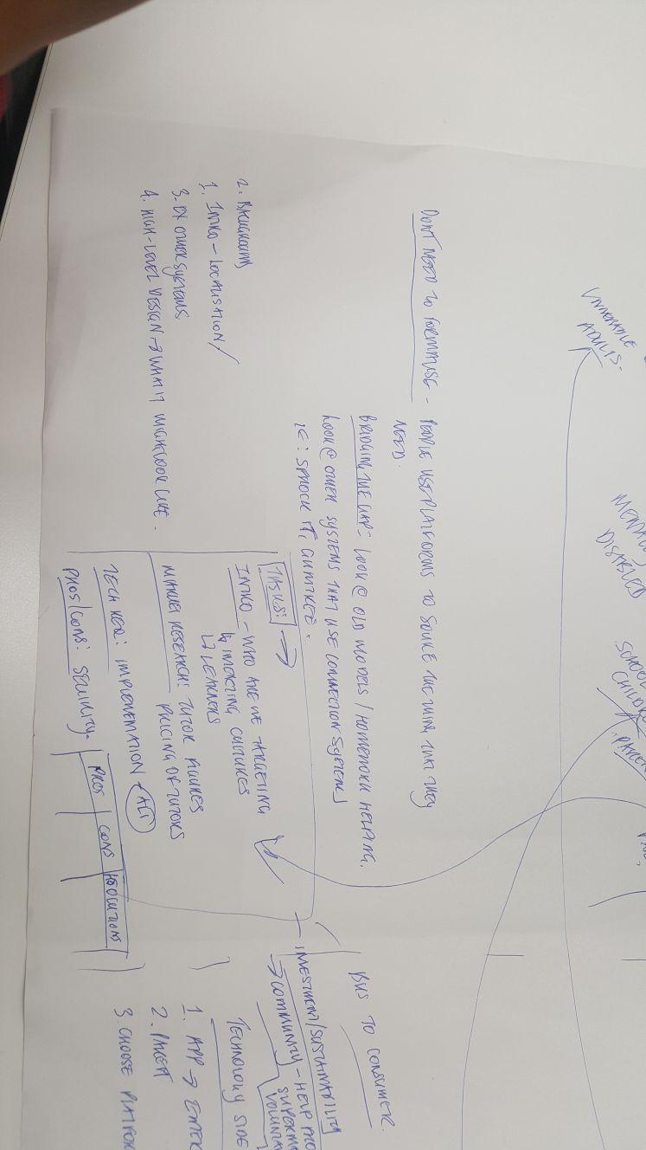

**FINDING USERS**

**How would we find users to discuss your project idea with?**

**PROBLEM STATEMENT**

A tool to assist “*children who are struggling with their learning*” this can include but is not limited to language assistance, subject assistance (help with maths, reading, science etc.).

**INSPIRATION**

Tinder - log in with various accounts, syncs your profiles and preferences, easy to use, can “swipe to like”, (we can use the login syncing aspect of Tinder, possibly the swipe aspect)

Amazon prime - go on website, has a pointer system so you can see locations and has a rating system that tells you whether it is cheap or expensive.

Mystery shopper - Market research app - you can pick a task and go to via a map inspiration

Quick - home help system matching students and elderly people - interactive map interface is easily accessible, voice recognition, rating system

[tick box]

hand in - take screenshots of hand in

**IDEA EXPRESSION**

*Solve the education need for children who may have a gap in their learning.*

**CUSTOMER DEFINITION**

Groups of people that will be using our system:

Teaching (Tutors): University Students

Taught (Tutee): Children (9 -16: year 5 up to GCSE),

Other main users: Parents of tutee, Schools

**PERSONAS**

|  |  |
| --- | --- |
| **Persona** | School child |
| **Photo** |  |
| **Fictional name** | Jimmy Stone |
| **Job title /major responsibilities:** | School student |
| **Demographics:** | Age 12 (UK)  Male  Lives at home with Mum, Dad & younger Sister  Goes to secondary school |
| **Goals and tasks:** | Jimmy is Year 8 and is struggling at school with his Maths homework, he wants to do well at school but just needs some additional help with his schoolwork. His parents struggle to help him because they have gaps in their knowledge. |
| **Environment** | Jack is a competent user of mobile phone devices and carries his mobile phone everywhere he goes. He has access to WIFI and has apps that use GPS location services. |
| **Quote:** | “I really need some extra help with my schoolwork” |

|  |  |
| --- | --- |
| **Persona** | School child |
| **Photo** |  |
| **Fictional name** | Omar Syeed |
| **Job title /major responsibilities:** | School student |
| **Demographics:** | Age 12 (UK)  (First language is:  Lives at home  Goes to secondary school  9 -16: year 5 up to GCSE |
| **Goals and tasks:** |  |
| **Environment** |  |
| **Quote:** |  |

|  |  |
| --- | --- |
| **Persona** | University student |
| **Photo** |  |
| **Fictional name** | Joey bloggs |
| **Job title /major responsibilities:** | University student studying Philosophy |
| **Demographics:** | Age 20 |
| **Goals and tasks:** | Wants to help children in his spare time and does not mind earning some extra money. |
| **Environment** | Studies in university alot and has some free time on the weekends |
| **Quote:** |  |

|  |  |
| --- | --- |
| **Persona** | Parent |
| **Photo** |  |
| **Fictional name** | [ ] |
| **Job title /major responsibilities:** | [ ] |
| **Demographics:** | Age [] (UK) |
| **Goals and tasks:** | [] |
| **Environment** | [] |
| **Quote:** | [] |

]

**Week 3: The Project Concept**

|  |  |  |
| --- | --- | --- |
| **Task:** | **Requirements:** | **Date due** |
| 1. Concept statement | Clear concise statement that can be used as a market survey | 23 October 2017 |
| 1. Confirm stakeholders | Having identified key stakeholders and their needs identify the functions that technology will perform | 23 October 2017 |
| 1. Confirm the information that will be handled and where will it come from | Confirm the information that will be handled and where it will come from  Map user needs to technology  Sketch a preliminary functional architecture diagram | 23 October 2017 |
| 1. Produce a preliminary use case diagram and from that use scenarios | Produce a case diagram | 23 October 2017 |
| 1. Use the scenarios to produce a sequence diagrams from which you produce a full activity diagram | Produce a sequence diagram to then produce a full activity diagram  (see list below of who is doing what you can use  <https://www.storyboardthat.com> to create the storyboard). | 23 October 2017 |

**Concept Statement**

The tutoring industry is currently valued at £2m (Guardian, 2016) , 40% of private tutoring was used by children in London and 1 in 10, 11-16 years old received private tutoring in England and Wales (Guardian, 2016). There seems to be a trend (Guardian 2016) towards more affluent families being able to provide their children with the option of having a private tutor to enhance and complement their education. This has alerted The Sutton Trust a charitable organisation aimed at increasing social mobility through education warns that at some point increase the inequalities of education for less affluent students (Guardian, 2016). The Sutton Trust an education charity has suggested that the Government should introduce a means-tested system to enable less advantaged children to benefit from private tutoring and close the education knowledge gap.

In order to help close this learning gap that has been created by more affluent students being able to access private tutoring, TutorUNI is an innovative connection tool that aims to solve the education need for children who may need assistance in their learning, but it is also aimed at children who do not have English as their first language.

TutorUNI’s aim is to be: ”***A tool to assist children who are struggling with their learning***”.

This can include but is not limited to language assistance, subject assistance (help with maths, reading, science etc.).] Parents can use the app to connect with a university student who can offer their child tuition at [£insert price] per hour, in the subject that the child needs assistance with.

The inspirations for the look of the TutorUNI app have come from as follows:

* Tinder: you are able to log in with various accounts, syncs your profiles and preferences. It is easy to use, you can “swipe to like”, (TutorUNI can use the log in synching aspect of Tinder for easy login for the university students. The possibility of using the swipe aspect can be used for the parent to select tutor options.)
* Amazon prime: There is the ability to go on to the website, it has a pointer system so you can see locations and has a rating system that tells you whether it is cheap or expensive. (The rating system could be used for TutorUNI for parents to see where there is a tutor available in their local vicinity and the tutor will also have a rating system attached to their pointer along with pricing).
* Mystery shopper: Is a market research app where you can pick a task via a map.
* Quick: is a home help system which matches students and elderly people. The app contains an interactive map interface which is easily accessible it also incorporates voice recognition and has a, rating system. All features which TutorUNI can adapt.

**Confirm Stakeholders**

**Stakeholders - Aaron**

The table shown below identifies our key stakeholders who will help shape and equip this project for success. The roles of each stakeholder differ on which stakeholders we look to involve into the decision-making process and how to communicate, cooperate and associate with them etc.

**Internal Stakeholders**

University Students

Parent

**External / Other Stakeholders**

Parents

Schools

Government / Local council

Retailers

|  |  |  |  |
| --- | --- | --- | --- |
| **Name and role of the Stakeholder** | **Benefits on projects** | **Impact on the project’s execution** | **Action requirements** |
| **University Students**    These stakeholders are considered as valuable members to this project. Acting as our primary market, individuals from this group are assigned jobs via the mobile app based on their availability and location from users. These jobs consist of one-to-one tutoring interactions with younger students in need of extra help with their school work in their homes. | · Knowledge of high academic standards can be shared and taught to children  · Flexibility/convenience with job offers and being able to offer their support instantaneously  Will give the university student valuable work experience that they would not necessarily attain if they were not using TutorUNI. | **Positive**  · Help children maximise their learning potential  · Offer the necessary assistance in areas which child is facing difficulties with  · Provide the role of a good disciplinarian in a student’s life    **Negative**  · Lack of knowledge in working with children  · Unable to connect with families to advise on child’s progress  · Not familiarised with new school curriculum reforms | · Awareness on working with children  · Liaising with parent to be well informed of child’s support program  · Take into account the awareness of child’s school curriculum reforms |
| **Children**    These are our targeted end users ranging from the ages of 11-16 (years 7-11). Those from this group will be the project's main focal point in supporting their educational needs and helping achieve improved grades towards their GCSE qualification. The users will be able to connect with academic specialists, from the field of interest, within their proximity to provide private tutoring sessions. | • Loyalty – more likely to be a source of repeat business and to recommend the service to friends and family  • Enhanced public image – helps build our brand and provides protection if there is a slip-up in overall service delivery  • More effective workforce – satisfied results of children’s education progress in school can help create a positive working environment | **Positive**  · Improved academic results  · Confidence established in their abilities of supported subjects  · Freedom from external problems and situations such as bullies, peer pressure and even boredom  **Negative**  · Learning difficulties  · Burden of extra home work along with that which is given from the school  · Students may have limited involvement in team sports and other extra-curricular activities outside of school | · Addressing and adhering to any learning difficulty child may face before tutoring begins  · Support offered will include any assignments/homework child is given from school  · Tutoring session will have to be agreed based on child and family’s availability |
| **Parents**    Considered as our secondary focal point from the children, these members will be able to connect with academic specialist via the mobile app by identifying the support that will be offered to their kids and also notice how safe their kids are with adults they do not know. | · Better tuition interaction - ability to contact parents directly would benefit from overall teaching experience  · Safeguarding security – involvement of parents would address consent needed for academic specialist to support their children. | **Positive**  · Better outcome for students’ progress  · The focus of child can be on studying  **Negative**  · Time – tutoring can absorb a substantial amount of a parent’s time  · Financial restrictions – not all families might be able to afford service if family income is already low | · Tutoring session will have to be agreed based on parent's and child’s availability  · Draw up a plan to market service at a affordable price range for all families. |
| **Schools**    This project will include the involvement of public schools in London to gain expert insight on the service and also to tailor the tutoring to the specific course materials that is offered. | · Creating excellent word of mouth promotion of services - sell services to other students who may be of interest  · Provide analysis on concepts and knowledge of what works best with certain types of students i.e. learning difficulties, attention span etc | **Positive**  · Gaining official approval from established public school  · Enhance overall tutoring experience for child  · Addressing current rules and regulations of exams and assessments  **Negative**  · Child’s learning habits/techniques may change through tutoring | · To develop and maintain child’s way of learning and understanding new study techniques through specialized handout material to explain difficult concepts using easy-to-understand ideas and examples |
| **Government / Local council**    This group’s inclusion within the project would primarily be to seek development of our business plan with financial and other supporting information. | · Building a public profile - Gain media attention which could lead to public recognition  · Free advice – providing signposting, diagnostic support and business improvement guidance | **Positive**  · Financial Support – government-backed grants  · Business support e.g. mentoring, consultancy    **Negative**  · Interference with business plan – changes in policies and procedures | · Set terms limits for all government partnering officials |
| **Retailers**    The position of this group within the project would be to attain a greater exposure of our target market and to utilise other marketing opportunities from their involvement e.g. school/loyalty vouchers. | **·**  Boost brand awareness - people will become familiar with our brand and reputation this includes local communities  · Resources available to gather feedback on current business environment/ market and use to improve/refine/develop service offer in order to remain competitive and sustainable | **Positive**  · Attract both tutors and children who will benefit from service  · Reduce promotional and advertising costs    **Negative**  **·** No control on product presentation to target market  · May offer poor customer service potentially harming our brand image | · Adopt guidelines for partners to control brand image and positioning of our core principles/standards |

*\*Stakeholder mapping diagram to follow once table above agreed with group [insert as follow up on Trello]*

**Functional Architecture diagram**

**System design**

The system design would mainly focus on accessibility and have a very simple interface. The reasoning for this is our target market. One of our main target market focus is children and parents, and therefore we have to take into consideration the fact that they might not be technologically savvy. This is why the UML shows you a step by step basic guide how the system would interact with the user.

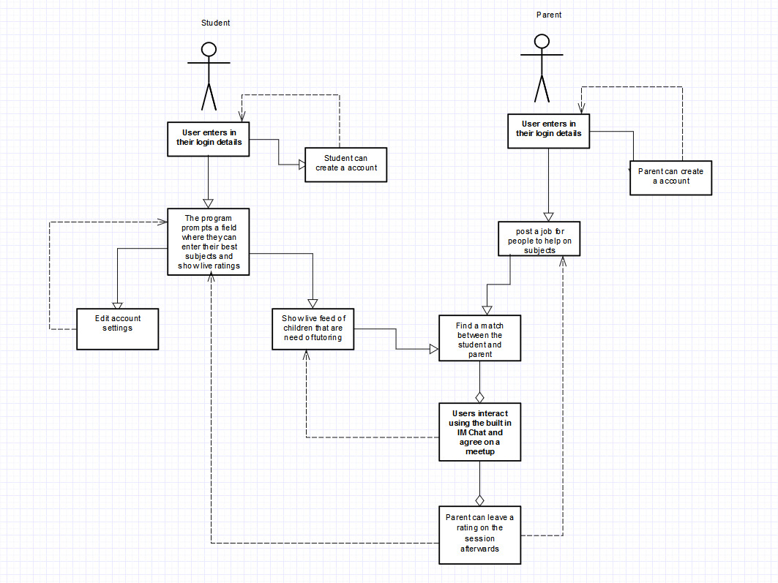

When the student enters the system, the first step is that they enter their login details, if not they can create a account which will take their university email address as well as their skills and languages Afterwards they can always check out their profiles and edit their settings this includes:

* Change of skills
* Leave a paragraph about themselves
* Add a picture of themselves
* Be able to deactivate their account
* Check if anyone has accepted their applications
* Check their previous messages

Then they can start finding matches such as who needs tutoring and start applying for the different job roles. They can also message their accepted roles and agree on meetup times and track their earnings made through the program.

**Parent**

The parent would have a different experience but it would start of very similar in a sense where they can enter in their login details and see what jobs they have posted and if they have any replies. They can start viewing the profiles of the students who have applied for their postings and decide to message one and accept them once they have agreed on one student. They can then leave feedback for their students whether the tutoring session was good or not.

The system would not 2 types of interface, one for the students which can be a little more advanced and would have more features while the other for the parents would have to be very simplistic to use. We have to consider accessibility issues like language barriers, therefore we would implement a multi language feature. We would also have a voice recognition feature where users can speak and it would try and detect the words so it makes it easier to type.

**Sequence diagram / Full activity diagram**

**Insert Storyboard**

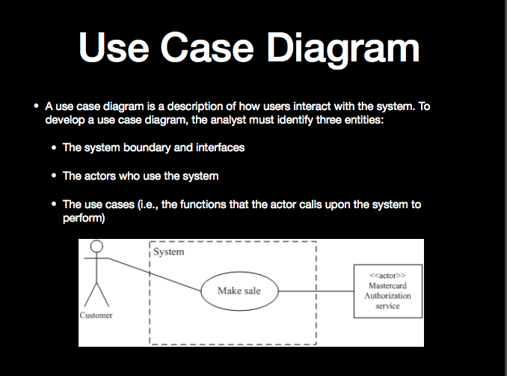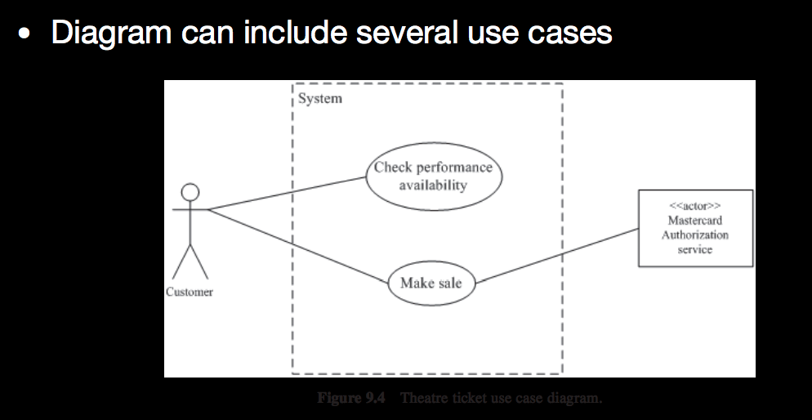

**Parent -child - Coreen**

**Parent - non english speaker - Zin**

**University student - Benji**

**Child - Aaron**

[A sequence diagram.]

**Target market - Benji**

Our primary target market consists of two groups:,

* both school children; and
* University Students at university.

The primary group of children will consist of school ages children aged, varying from ages 9 to 16 years old (year 5 to GCSE), which targets Year 5 up to GCSE learning.

This primary market has been targeted as e reasoning behind this is that, at Year 5, children at this age may be preparing will begin to prepare for their 11+ exams, alongside their SAT exams, and therefore may need added support alongside their school education.

Our secondary target user is University Students. This target market has been identified as University students may want a facility where they can earn money whilst studying whilst being able to use their knowledge to tutor children. The app will require the student to log in via their university portal to confirm authenticity. The student will then be able to find local jobs to help tutoring jobs. The student will then be able to tutor, and earn an income.

A middle target market has also been identified this group will consist of however consists of other groups, such as parents, schools and possibly even retailers:

In London alone, more than 40% of pupils have had a private tutor at some point of their school career, which usually costs on average £27 an hour. Therefore, parents may struggle to finance this additional cost, and their child may suffer academically. Therefore, parents will be able to set up a profile for their child and can find them more affordable tutoring help from local students.

Many schools have interactive learning portals, where parents can see student profiles, displaying student academic information such as reports, as well as homework. Schools could partner with our application, giving the then University ‘tutor’ access to the data, allowing them to further help the child by being able to prepare student specific learning help.

Retailers have been identified as a target market as many of the retailers run schemes supporting local businesses and ideas, where contributions are made to provide financial aid to these organisations. Waitrose for example run a community matters scheme, where after each purchase the customer is given a token, to which they can then ‘vote’ which percentage of the monthly charity allowance (£1000 for large branches, £500 for express branches) goes to which organisation. Our application could apply to one of these schemes, providing funding and support.

TutorUNI - Revenue (Zineddine Daif)

A very important aspect of every profit orientated business is to convey a reasonable income. This income can be seen as the significant measure of effectiveness of the business and this is why revenue can be seen as a main priority. TutorUNI is going to be a service were individuals (parents) can request a tutor for either their children or themselves. TutorUNI are initially focussing on University students here at goldsmiths as oppose to the rest of the UK as the application will still be in the development stage. Once the application proves that it is a solution to a particular target market’s needs we plan to give other university students around the UK the opportunity to use the application.

https://www.imf.org/external/np/pp/eng/2015/020215a.pdf

Unlike other services, the hiring of a tutor and the payment is handled entirely through the TutorUNI app rather than with the tutor. The main source of revenue coming in from this application will be the percentage we take of each transaction made in the application. TutorUni will take a 10% cut of the total revenue of each transaction made between the tutor and the parent. This transactional cut is considerably low compared to other similarly structured revenue models.

For example, a very well known company known by the name of Uber earns its revenue through a very similar process; Uber however charges a much larger cut which is taken from each transaction made between the Uber driver and the client. *“Drivers keep 75% of the total fare price for a given ride. Uber takes 25% of the fare.”* .

http://www.alvia.com/how-much-do-uber-drivers-make/

The reasoning behind this is the idea of keeping the cost of a tutor low for those who cannot afford standard private tuition. The cost of tuition for most parents is prohibitive however this application will give each parent the right to provide their child with a tutor regardless of their income. “35% OF PARENTS ARE NOT USING A TUTOR BECAUSE IT’S TOO EXPENSIVE” (Cooke); there are countless articles all over the web slating high tuition fees and ultimately, something needs to be done.

University students across the UK who will be using this application will be entitled to 90% of each transaction made between themselves and the parent. The money made will be debited into their bank accounts each week. The application will be very profitable to students and to those who are struggling to find a part-time job which they can be flexible with during their studies. A survey of 2,128 students found that nearly half of students have a part-time job, including a third of students now working part-time during term time. More and more students are looking for part-time work and TutorUNI can provide an income where students can work whenever and wherever they feel.

<https://www.theguardian.com/education/2014/aug/11/students-work-part-time-employability>

**Week 4: Researching the Market & State of the Art**

|  |  |  |
| --- | --- | --- |
| **Task:** | **Requirements:** | **Date due** |
| 1. Research key terms for concept statements | Distill from your concept statement the key terms that you can use as search terms. | 31 October 2017 |
| 1. Research competitors | Search for competing products directly and from reviews, trade sites, press reviews and customer reviews. | 31 October 2017 |
| 1. Research regulations | Look for any regulations and standards that will constrain your concept. | 31 October 2017 |
| 1. Research any academic work that is relevant | Using Google Scholar find any academic works describe theory or emerging research that is relevant to your concept. | 31 October 2017 |

<http://www.sitters.co.uk/>

Competitors - **[Zineddine Daif]**

1. Who are our competitors?
2. What products and services do they currently have?
3. Who are their target audience?
4. Who are their competitors?
5. How well are they doing?

The application store is vast, it increases in size and apps constantly and inevitably different ideas and concepts will inspire others to create similar applications. The bar is raised each and every day and during our current present the chances of creating a successful application may seem just as high as winning the lottery. There are hundreds of tutoring applications which all provide different features and ultimately every single one of them is building upon their foundation to create the perfect tutoring application.

The first competitor I looked into which provided an online tutoring service went by the name of **Cheg Tutors**. Cheg Tutors provides homework help and online tutoring. It allows any student to get that ever so needed one-on-one tuition from expert tutors from top colleges around the country. Unlike TutorUNI the tutoring is all done online on either live video chat or through a messaging service. TutorUNI provides a more practical experience and as said by [MICHAEL GODSEY](https://www.theatlantic.com/author/michael-godsey/) students are more engaged and focused when an actual tutor is present as opposed to staring at a bottomless screen for hours on end. The application provides tuition for any subject and specifies a target audience of anyone in need of tuition regardless of age.

**Cheg Tutors** have an interesting revenue model where prices start from just .50/minute. The company offers each new customer 30 minutes of free tutoring so that each student know what kind of experience they are letting themselves in for before they spend their money. Each tutor is paid 20. Per hour as a minimum and the 50. Is applied to the exact number of minutes accumulated during a given week. This company is also based in America and are not available in the UK.

(could not find information on how the business made money)

**SAT up** is a tutoring application which gives students tuition without the use of an actual tutor. SAT up is a tuition application which specialises in SATs which means the audience they are targeting are aged between 6 and 11 y/o. The application provides a number of really interesting features including In app games to help with studying, personalised workouts and more. An interesting feature the application provides is the personalised workouts which become more and more suited to the student as they progress with the workouts each day. The app also provides feedback from tutors which will take at maximum 24 hours to reply.

**SAT up** charges a monthly fee of 4.99 which allows unlimited use of all of the features they have to offer. The application asks the user for a debit card which will get debited each month. The price is very affordable and considering the features very good value for money also.

**Tutree** is an application I found online which is very similar to our concept TutorUNI. Tutree provides help on homework, revision help with exams, general tuition and more. The application says they can provide you a tutor within minutes once requested and give the students the option to compare the different tutors available in the area they are within. The application also has a GPS based service and provides a map with areas where tutors are available. The application has a built-in rating system so that students can see ratings of each tutor available to them. Both student and tutor have the option to rate each other out of 5 stars and also have the option to leave a review. Payments are made through the application once a debit card has been added to the account.

Each tutor has a fee which is shown on their profile, however this fee is not fixed and can be discussed in the messaging service that the application provides. Most fees range from 25. and up. The application takes a cut of each transaction made between the client and the Tutor.

(I could not find this percentage)

//Not finished

**What is their Revenue Model [Not complete]**

What is their revenue model? **[]**

1. What legal safeguards do they have in place?
2. Are they responsible for the target market using their servth aice including, health and safety (What are the health and safety regulations)?
3. What are the licences required?
4. Comparison between our services?

Indirect competitors and direct

10. What are the costs and how to maintain it?

[INSERT TEXT HERE]

**Reviews - [Benji]**

[Asses competitors using research from forums, reviewing sites or even primary research such as recording or videos.

So ask the questions from **COMPETITORS** to users

Ask users whether they like the revenue models and what they could improve on competitors]

**Tutor Hunt**

The first competitor looked at is Tutor Hunt. On the UK Trustpilot website (<https://uk.trustpilot.com/review/www.tutorhunt.com>), there are 840 reviews, and from these 88% of them give Tutor Hunt the top tier rating, which is excellent. Some of these reviews are as follows:

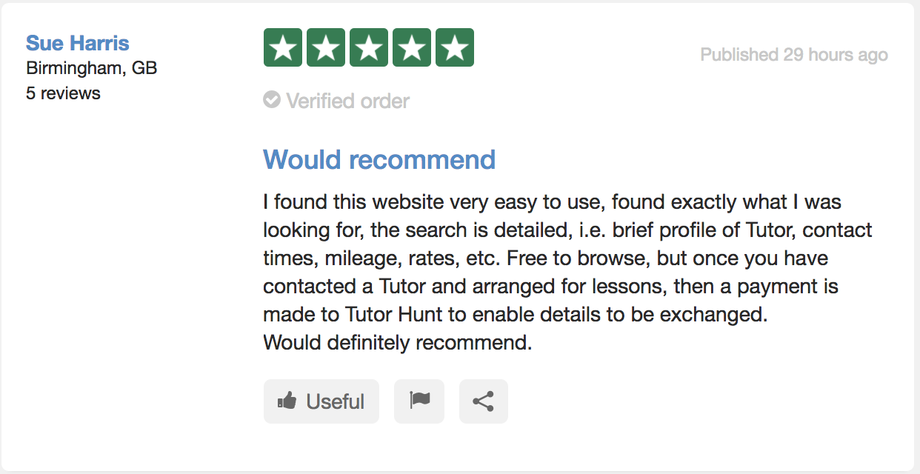

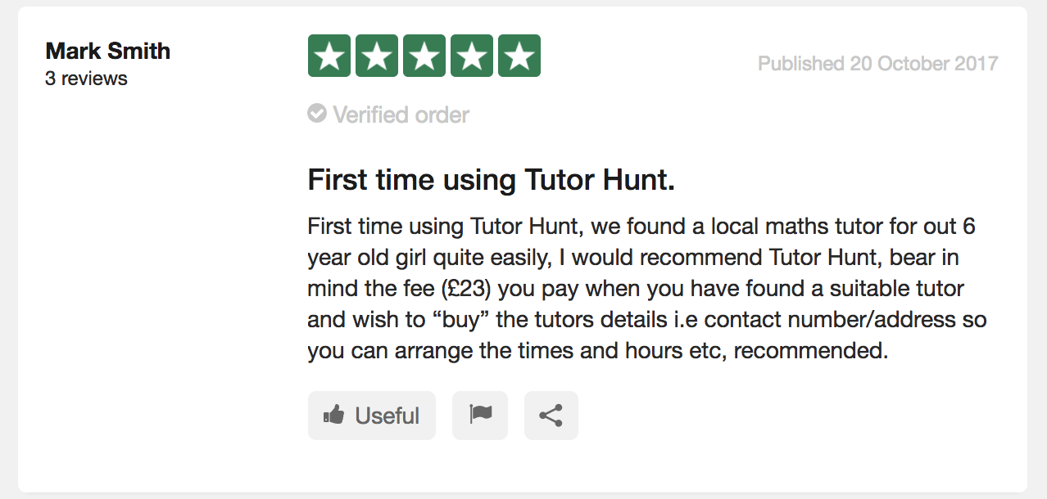

From the 88% Excelend reviews, users emphasise the simplicity of the site, and how it is clear to use, and the use of short descriptions for the tutors allows those seeking tutoring and quick way to sort through the results and find a suitable match.

Although most have positive reviews, 1% of the users have only rated 1* rating, some of which can be seen below:

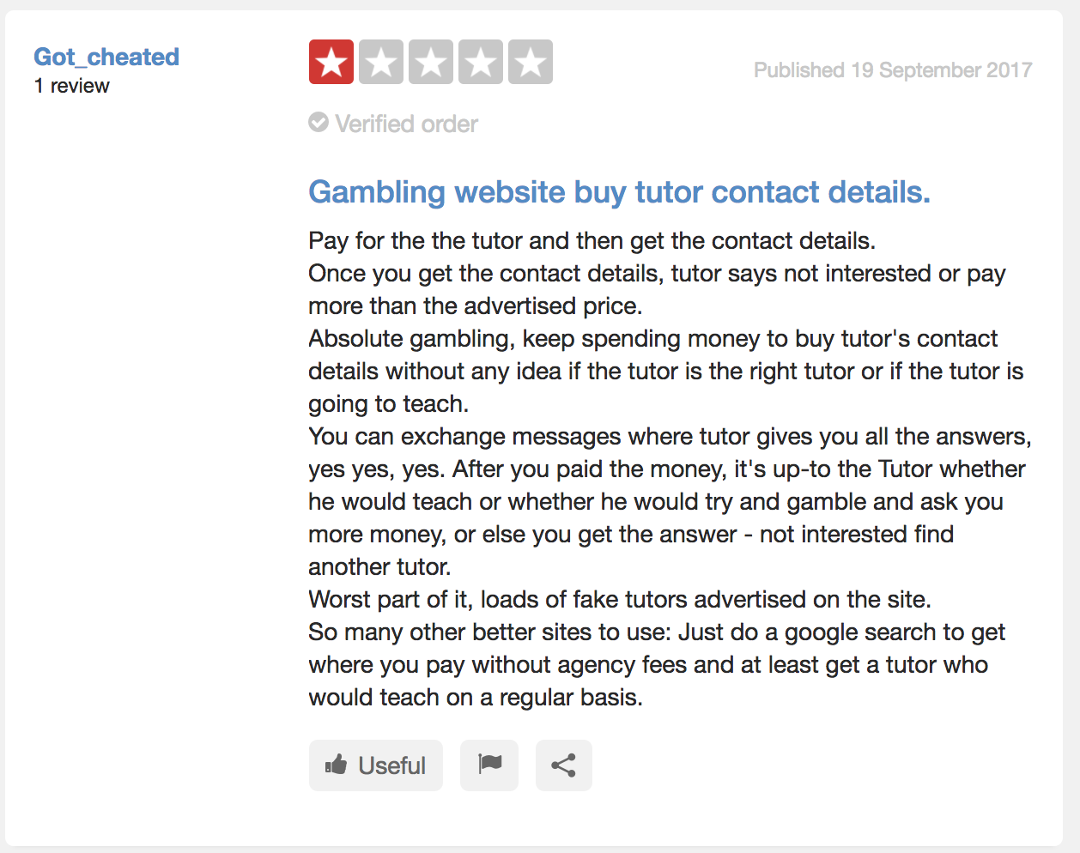

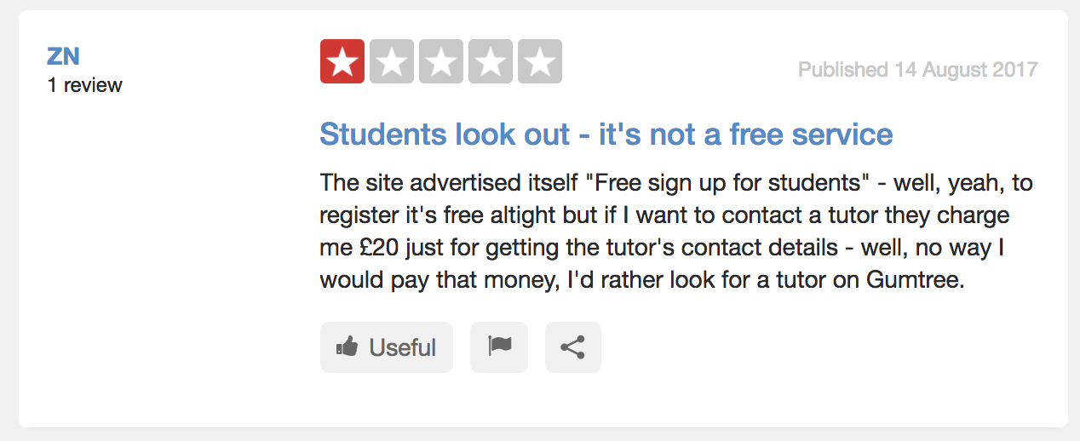

Although the minority, these reviews highlight some issues users have faced, especially highlighting the fact that, although they may have paid to get a tutors contact details, the tutor may then not chose to teach them, effectively meaning the user has ‘wasted’ their money. Other issues highlighted are the the uncertainty of how the site is used (how people pay for the service) alongside some people paying to then have unreliable tutors.

Other sites such as Site Jabber (<https://www.sitejabber.com/reviews/www.tutorhunt.com>) have nearly 30% of their reviewds 1*, with most reviewers emphasising that the high costs put them off the service.

**Legal - [Coreen]**

*Legal implications when working with children?*

Whilst look at a website called TutorCruncher which is a website that helps small businesses take care of their invoicing etc, a Start-up consultant has given a few pointers on the legal aspects of starting a tutoring company.

[<https://tutorcruncher.com/legal-implications-when-starting-a-tutoring-business/>] [Accessed 26 October 2017]

Disclosure and Barring Service (DBS) Checks:

All jobs in the UK that involve working with children require a DBS check to be carried out this is a detailed police check to ensure that the person that is being checked does not have any restrictions on their ability to work with children. Every potential tutor also needs to have their identity verified with the following:

* Passport;
* Two references from employers;
* Proof of being eligible to work in the UK;
* Educational qualifications

Confidentiality Agreement

It is suggested by TutorCruncher that a confidentiality agreement should be signed by all tutors in order to protect the interests of the client(s). This could include, but not limited to, high net worth clients (the confidentiality agreement would ensure that any confidential information of the client will be protected) as Tutors may come across confidential information within the client’s home whilst tutoring the child.

Terms of engagement

There should be terms of engagement in place so that it is clear on what terms the tutor will be employed. For example, will the tutor be self-employed? If they are to be employed by you will they be paid weekly, fortnightly, monthly? Will the tutor be responsible for paying tax, will they be entitled to holiday pay or sick pay? If they are to be employed by you what protection will they be entitled to. Will the tutor be working with your exclusively or will they have the freedom to work with other agencies (will this cause a conflict of interest if they are working with other agencies). The terms of engagement should be signed on commencement or just before employed starts.

Social Media policy and advertising

There needs to be some consideration taken when advertising the tutoring business as there may be legal implications of how you advertise for example giving out flyers outside of a school playground to parents. There are rules and regulations in place on how you should advertise and not to have misleading advertisements and direct marketing.

(Advertising Standards Authority)

Data Protection Act

What are the rules around Data Protection Act

Syllabus

How are we going to improvise on the risks involved?

How would we acquire certain licences (including costs)?

How much is a DBS Check?

How much does it cost to right a disclosure agreement/confidentiality agreement?

Advertising Standards Authority

Who are responsible for the risks (if there were any to happen)?

Dispute resolution

**How do our competitors display their legal information - [Please add your name]**

How are we going to portray the legal terms to the users of the app?

Do our competitors have the legal terms in a transparent way?

Data protection, can we get data from the university for their students involved?

Can we get departments or tutors to verify the student's’ account physically (By visiting the tutors)

**Licence - Aaron**

What licences are required?

- ***Apple Developer Program Agreement***

The Developer Program Agreement is Apple’s fee-based subscription that allows members to publish apps for devices based on the business’s mobile operating system to the app store.

Members must be a registered developer/Apple customer in order to submit their application to Apple for approval for them to make the app available via the iTunes app store. If members plan on charging for the app, Apple keeps 30% of the chosen sales price for the app to cover housing cost, DRM (Digital Rights Management) protection, and credit card etc. This agreement costs developers £99 a year which is renewable once expired.

Included in this program, Apples have incorporated the intellectual property license which allows for distribution of the app to end users, including hosting and displaying the app, making copies thereof and allowing end user to download the content itself. This would ultimately hold the right type of protection to stop people stealing or copying; the name of the app, our inventions, the design or look of the app etc.

- ***Google Play Licensing***

Google Play Licensing is a network-based service that lets an application query a trusted Google Play licensing server to determine whether the application is licensed to the current device user. The licensing service is based on the capability of the Google Play licensing server to determine whether a given user is licensed to use a given application. Google Play considers a user to be licensed if the user is a recorded purchaser of the application.

Similarly, to Apple, Google Play takes also 30% from in-app purchases income however, their pricing differs as a one-time fee of £25 must be paid to obtain this license.

**- *End-User License Agreement***

This license applies to the agreement put in place between a user who purchases, installs, or downloads software, and the provider of the software. This agreement is typically presented to users for acceptance during the installation or set-up stage of the software. A pop-up window that prompts a user to check a box that shows they accept the terms before continuing is a very common and effective way of obtaining acceptance for legal terms and conditions.

**How to obtain & how much is cost?**

**- *Privacy Policy***

An essential license of the agreements where we’ll need to specify what personal data we’ll be collecting from our users. This document will also explain how we’ll be handling information of our users, client or employees gathered within our operations. Privacy Policy agreements is mandatory because we’ll collecting data that can be used to identify an individual. Personal data is any kind of data that could identify an individual such as:

- Email address

- Device ID

- First and last name

- Billing or shipping information

Both iOS and Android apps is required to have a Privacy Policy if we access, collect and transmit personal information from our users. This requirement is further enforced by Apple and Google for all apps operating in their App/Play Store.

**How to obtain & how much is cost?**

Is there any insurance policies?

**SOURCES:**

***1.******https://developer.apple.com/programs/how-it-works/***

***2.******https://www.apple.com/uk/legal/sla/***

***3.******https://developer.android.com/google/play/licensing/index.html***

***4.******https://www.gov.uk/help/privacy-policy***

***5.*** [***https://www.keystonetutors.com/policies***](https://www.keystonetutors.com/policies)

**Costs - [Aman]**

**Costs - [Aman]**

‘The Tutor Pages’ is an online company with a website that helps access private tutors all around the UK for students and all other consumers. The website gives an insight of how customers would find their perfect private tutor. There is a search bar for customers who have a specific ideology of which type of tutor they would like to book for themselves/children. There is a variety of different subjects with all different level e.g. GCSE - A-Levels. You'll be able to compare tutors, rates and experience, and then contact a tutor directly, free of charge.

(<https://www.thetutorpages.com/private-tuition-fees>)

**Fees**

As tuition fees doesn't come free, the rates have increased rapidly over the years making it less affordable for many parents and students.

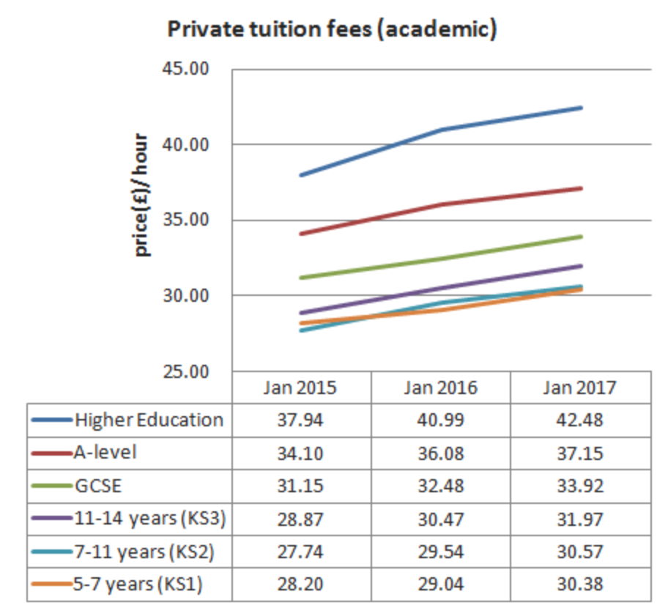

The Tutor Pages distributes yearly information on the normal hourly rates which private guides charge over the UK. The information is exact in light of the fact that it depends on the rates charged by more than 2000 free private tutors, and not on private agency data.

* In 2017, for academic tuitions for up to the age of 14, private tutors are charging on average between £30.40 and £32 every hour.
* GCSE educational cost is averaging around £33.90 every hour, and A-level educational cost is charged at by and large £37.20 every hour.
* For higher level studies like university, the charge increments to, on average, £42.50 every hour.

**Online Tuition & Independent Tutors**

The Tutor Pages have an indepth overview report into **online tuition** cost demonstrated that many tutors charged a similar rate when they were tutoring on the web. In any case, some reduced their rates somewhat. It shows in the study, around a quarter expressed that they charged 70%-100% of their face-to-face fee.

**Key Findings:**

* Around 80% of UK tutors use Skype to tutor online;
* The cost of online tuition is about the same as face-to-face, or slightly less;
* Payment is usually made by bank transfer, or through Paypal;
* Parents will often choose online tuition because of the convenience, the lack of local tutors, or because they’re living abroad;
* Online tutors report a number of advantages, such as flexibility in lesson scheduling and no travel costs;
* Some online tutors believe that students can learn better online compared to face-to-face;
* Online tuition is most popular for secondary school subjects or for adult learning.

**Independent tutors** advertise in the [Tutor Pages directory](https://www.thetutorpages.com/tutor-search), meaning that you can contact them free of charge. Using the company’s service meaning you’ll avoid the extra cost of agency commission or ‘finder’s fees’. Tutors have placed adverts the webiste site. So as well as it is free of charge, you don't even need to login: just use the each bar above. Unlike a tuition agency, The Tutor Pages does not get involved in payments. Each tutor displays their own rates, and will explain their terms of business when you contact them.

Private tutors’ fees can vary considerably, so these are the following factors which can influence fees:

• Experience

• Qualifications

• Track record

• Travel costs and travel time

• Online tuition vs face-to-face tuition

• Preparation required

• Cost of materials

• Subject level

• Initial assessment

• Discounts offered for block bookings

**Comparison and Safeguarding - (Fahim Ahmed)**

I will be speaking about my tutor website…  
What they use in their websites to get there customers (students etc)  
How they present this for e.g. (advertisement)  
Why students would use this service?  
Safeguarding mainly  
prices  
  
https://www.mytutor.co.uk/how-it-works.html  
Mytutor website - there main heading is, Find your ideal tutor for one to one online lessons.   
Some of My Tutors features -   
  
Face to face video  
(where students chat to their tutor by live video, helping to build that important one- to one rapport)  
  
Also have a document upload   
(resources placed here, past papers and pictures of diagrams etc)  
  
Collaborative tools  
(an online interactive whiteboard can be used by both tutor and tutee)  
  
  
There costs vary depending on which of their service you use - for e.g.  
  
Take one-to-one tutorials from £18/hr  
  
Once you've found the right tutor, you can book sessions affordably and pay as you go. Payments are made easily and securely on the site. By learning online, you cut out travel costs and make savings of up to 40%.  
  
This website is really focused on the aspect on the safety of the students. These are some of the policies which they follow that are stated on their website.  
  
  
There tutors have to be verified, therefore they take the procedure of their students safety and concerns as priority. The communication which takes place online they will keep private and won't share the information around due to rules and regulations. And data protection acts. In addition to this all the sessions are recorded and also can be played back yourself after a month. This can be beneficial for both the tutor and tutee.   
  
  
This above is what they believe.  
  
  
  
  
  
This is just how to get started in there website, if you want to join whether you're not sure if this is the correct or best tutor site. Well some tutors give a free trial first time you meet however some tutors may charge. As you can see the price range above it differs. It starts from as young as 11+ for gcses. I believe you can be as old as you want to use this service. No age restrictions.   
  
Therefore Using for this service what does it get you?  
  
Well you get one - one tuition  
(if you have time read this, http://www.telegraph.co.uk/education/2017/10/10/private-tutoring-time-invested/  
Explains what parents want in a tutor, e.g. the build up of rapport between tutor and child)  
This article also explains certain aspects which if you take away change the meaning of tutoring. For e.g.  
  
Sharing a tutor between friends reduces the cost but also removes one of the main advantages of tutoring, namely one-to-one attention. The exception is foreign languages, where groups could help in conversation practice, provided pupils are at a similar level.  
  
  
You also get your recorded sessions  
Therefore you can play this back at later stages, go through certain topics or the video more than once.  
  
Interactive learning environment   
This is like a online tools environment. Interactive learning takes place such as, having quizzes or diagrams. Online board etc. This is getting much popular lately and a lot more students are using this than before.  
  
You also get written feedback  
This is where students can get feedback of how they are progressing or what their good and bad flaws are. How can they improve? What can they improve on? When the tutors can give them feedback on how well they are progressing and also the students can ask questions.  
  
HOWEVER I BELIEVE WHAT WOULD BE DIFFERENT WOULD BE IF ALSO THE STUDENT CAN GIVE FEEDBACK ON THE TUTOR. NOT LIKE A REVIEW HOWEVER A FEEDBACK WHERE THE TUTOR CAN TAKE ON BOARD WHAT THEY CAN IMPROVE ON.  
  
Safeguarding   
1.1 MyTutor (MTW) is committed to ensuring the highest possible standard of safeguarding. The personal safety and wellbeing of each student and tutor using MTW is paramount.  
1.2 Our site was developed with the aim of ensuring that tutorials take place in a safe environment. This is reflected in a number of key built-in features and defined a set of policies and procedures for the students, parents/responsible adults and tutors who use this service  
  
This shows that mytutor want their students to get the best learning experience in the best way and in a safe environment in safe hands. For this they have set rules and regulations to keep their students safe.  
  
2.Legislative Framework/Related Policies  
2.1 These policies and procedures aim to ensure that all persons using the MTW services can do so safely within child safeguarding standards and UK law.  
These policies should be read in conjunction with the MTW Terms and Conditions and the procedures.  
They have to follow the child safeguarding standards and the uk law.  
http://ec.europa.eu/justice/fundamental-rights/files/rights_child/standards_child_protection_kcsc_en.pdf  
This site above explains some of the standards which should be implemented when safeguarding a child. Explains the risks, what to do etc.  
  
3. Aims  
3.1 The aim of this policy is to safeguard all students and other persons using MTW system whilst they are within a tutorial session.  
3.2 This policy document contains the responsibilities of all persons using MTW, including tutors, students, parents (responsible adults) and teachers.  
3.3 It is important that all persons using or working on behalf of MTW are aware of this policy and have familiarised themselves with the detailed safeguarding procedures.  
3.4 This policy should be read and understood before engaging in any activity arranged through MTW and the responsibilities and procedures therein adhered to. Contravention of the policy document could lead to suspension and/or barring from the services.  
They take their safeguarding seriously and as they said contravention to follow these procedures can lead to suspension or barring from the services….  
Therefore everyone working here need to know the policies and follow it to become familiar with this.

**WEEK 5: CONCEPTUAL PROTOTYPE**

|  |  |  |
| --- | --- | --- |
| **Task:** | **Requirements:** | **Date due** |
| 1. Map out timescales | Map out your project as best you can to meet the objectives within the timescales that you are working within. | 13 November 2017 |
| 2. Major tasks and sub-tasks | Identify major tasks and sub-tasks that will contribute to achieving the tasks. | 13 November 2017 |
| 3. Allocate | Attribute resources to those tasks | 13 November 2017 |
| 4. Milestones - internal/external | Identify milestones, both internal and as external deliverables for your project | 13 November 2017 |
| 5. Identify critical path | Sequence the tasks, identify the critical path and where you have slack time in the project sequence. | 13 November 2017 |
| 6. Identify project management tool and construction of Gantt chart | Select a project management tool and construct a Gantt chart for your project . | 13 November 2017 |
| 1. Identify prototypes to use | Identify which conceptual prototypes you will need in order to validate your project with users and stakeholders. | 13 November 2017 |
| 1. Identify conceptual prototypes | Identify which conceptual prototypes you will need in order to answer any technical open questions that you may have. | 13 November 2017 |
| 1. Schedule for using prototypes | Prepare a schedule for using your prototypes to answer the questions they were designed to answer. | 13 November 2017 |

**Map out timescales**

**Major tasks and sub-tasks**

**Allocate Resources**

**Milestones: External and Internal**

**Critical Paths**

**Project Management tools**

We have decided to use Zoho Project Management tool in order to track our project. This management tool enables us to track the progress of the project. The tool enables us to set milestones, and allows the connection between milestones and tasks that are set for the group to complete.

**Conceptual Prototype**

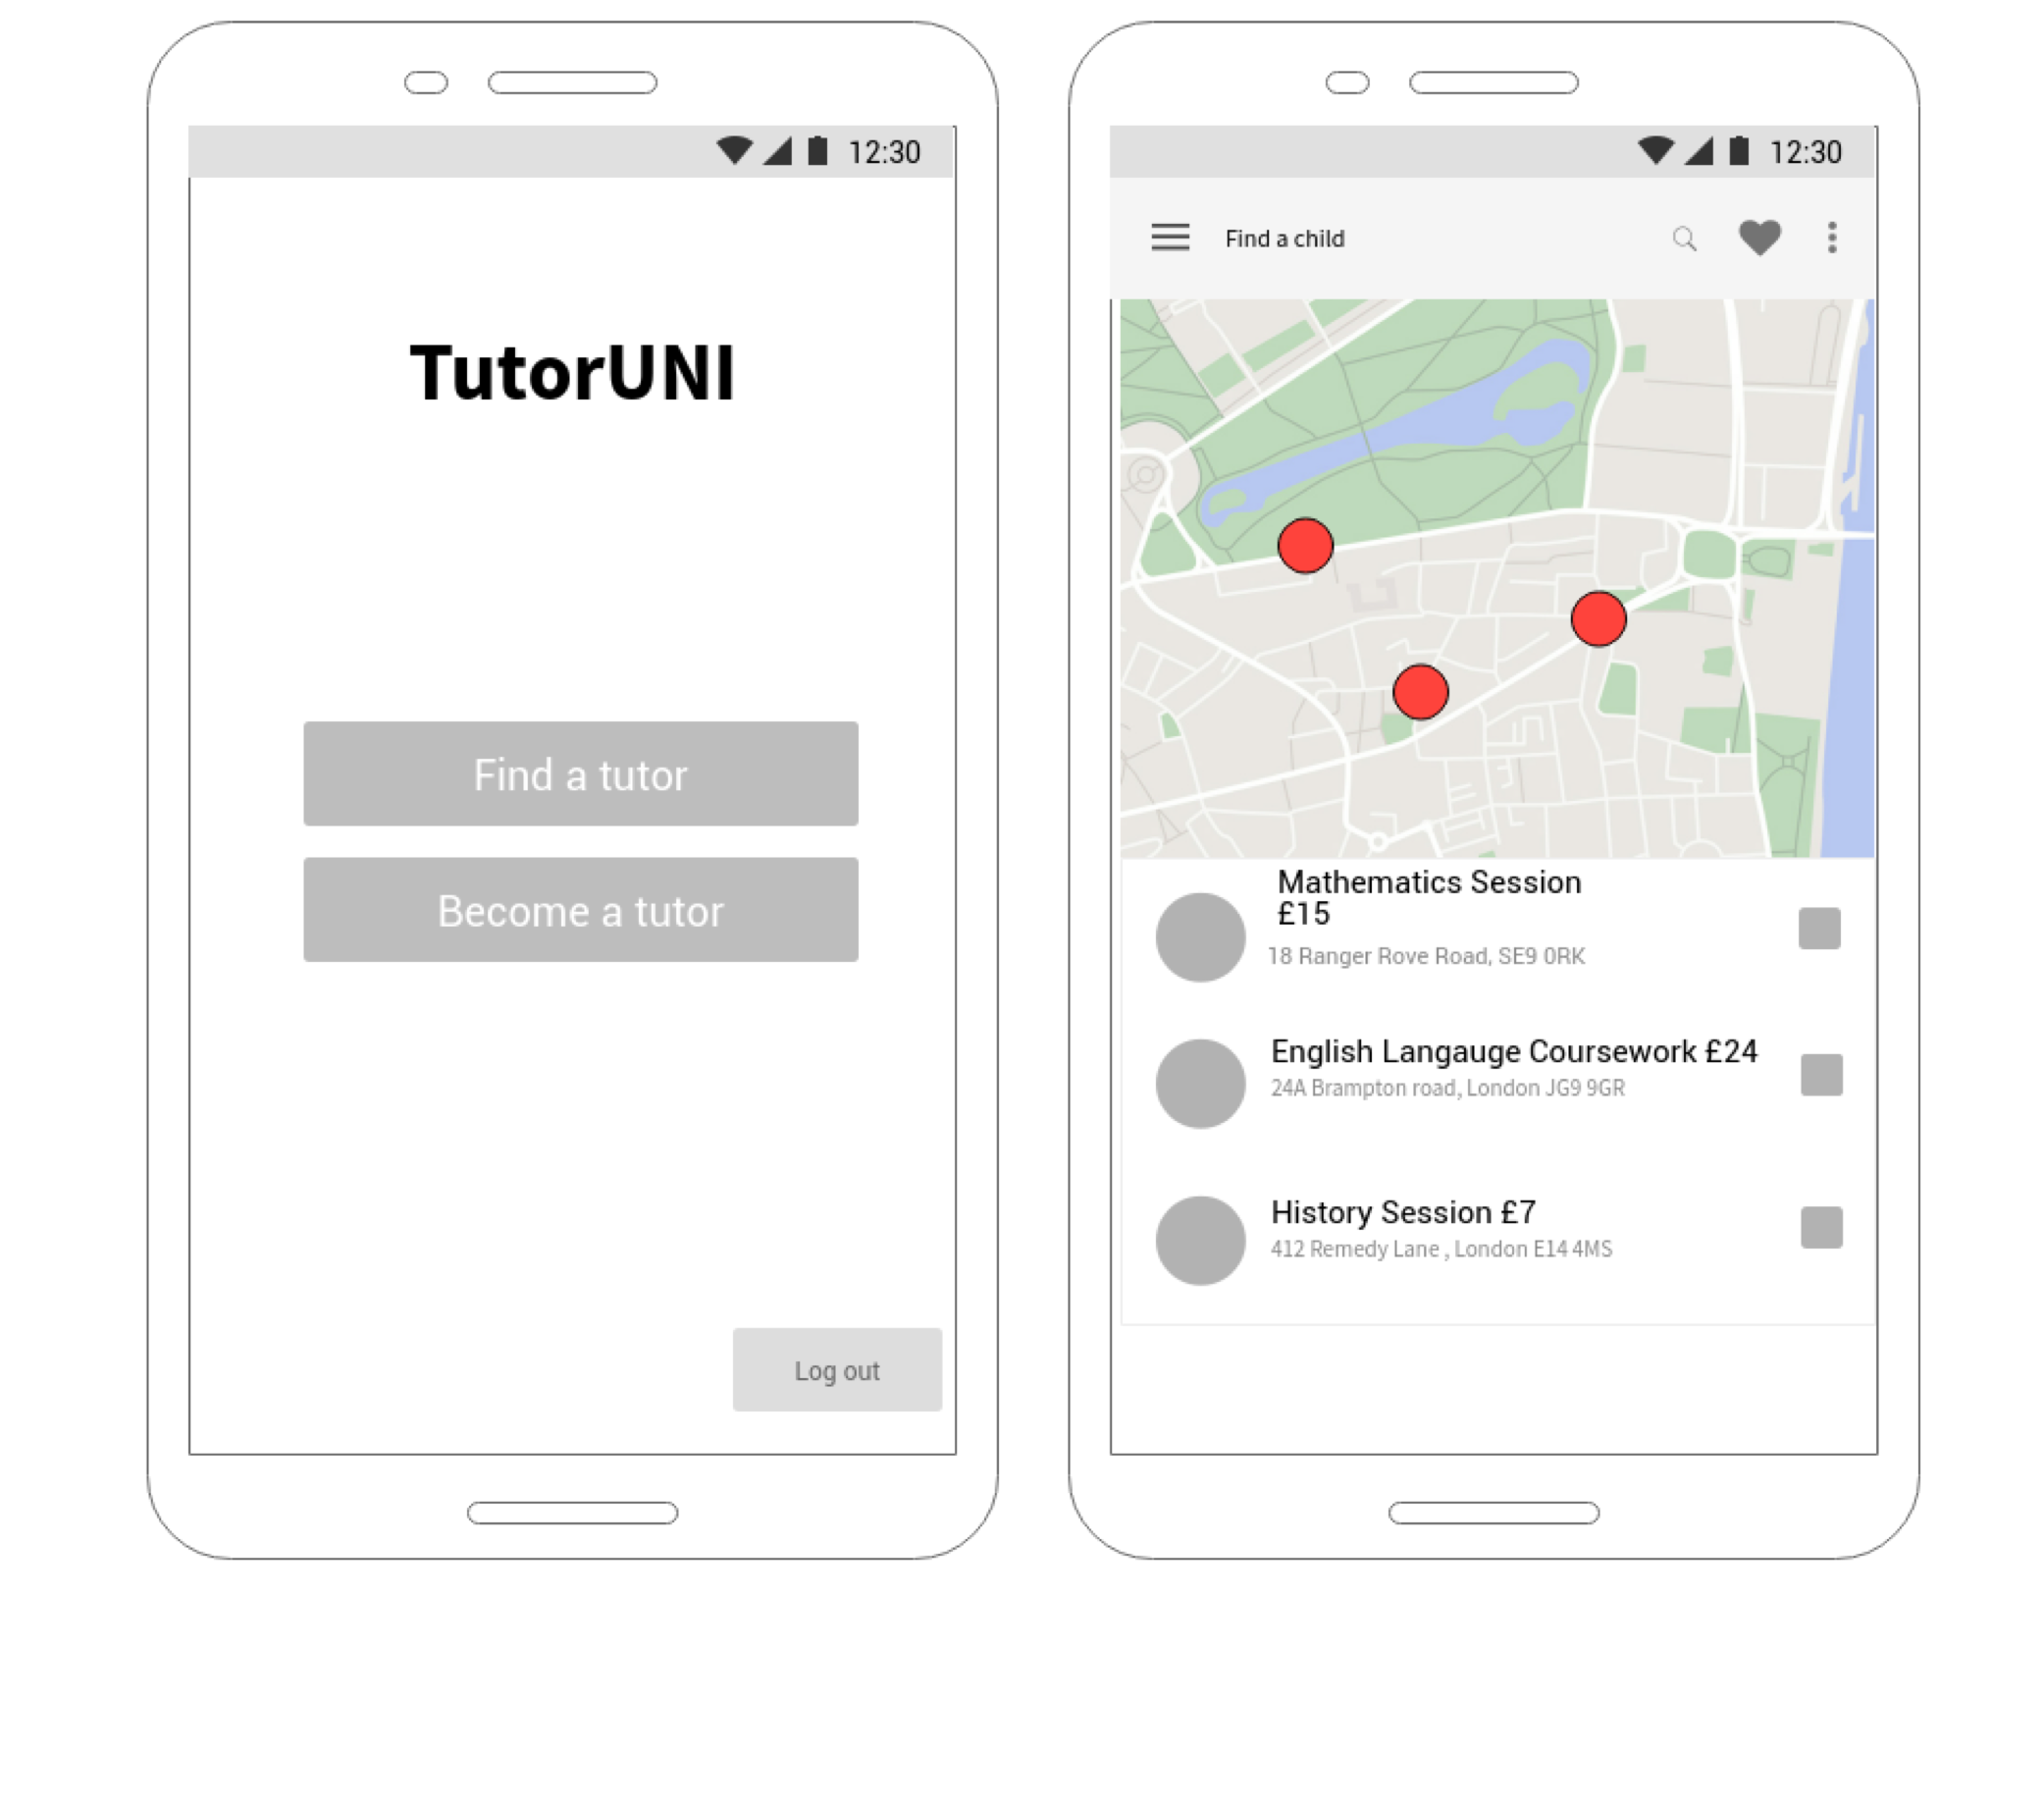

**WEEK 6:READING WEEK**

**WEEK 7: FUNCTIONAL PROTOTYPE**

|  |  |  |
| --- | --- | --- |
| **Task:** | **Requirements:** | **Date due** |
| 1. Identify functional prototypes | Identify which functional prototypes you will need in order to validate your project with users and stakeholders. | 21 November 2017 |
| 1. Identify which type of functional prototype will be needed | Identify which functional prototypes you will need in order to answer any technical open questions that you may have. | 21 November 2017 |
| 1. Devise a schedule and Q&A | Prepare a schedule for using your prototypes to answer the questions they were designed to answer. | 21 November 2017 |

**Student Prototype**

In order to test out Student users we will be using a prototype which will test the validity of the user interface. The prototype is in the form of a powerpoint presentation which has some interactivity. This allows the user to make basic click functions to see how the functionality of the potential website will work. The functional prototype also has a built in poll so that we can collaborate live feedback with users when they engage with the powerpoint presentation.

*Feedback from the Student Prototype:*

**Parent Prototype**

In order to test out Parent users we will be using a prototype which will test the validity of the user interface. The prototype is in the form of a powerpoint presentation which has some interactivity. This allows the user to make basic click functions to see how the functionality of the potential website will work. The functional prototype also has a built in poll so that we can collaborate live feedback with users when they engage with the powerpoint presentation.

*Feedback from the Parent Prototype:*

**Logo Names and Ideas**

**See powerpoint**

**Survey questions**

Slide 2: Is it clear how you log onto to the system according to what user you are?

Slide 3: Login: Is there enough information for you to login clearly? Any suggestions to make this process easier

Slide 4: Account creation: Is there enough information for you to create an account? Any suggestions to make this process easier

Slide 5: Profile Page:

Is the information about your profile displayed clearly?

Is it easy to edit?

Does it require any further information?

Slide 6: Tutor Request:

Is it clear what this page is asking for you to do?

Is there any further information that is required.

Slide 7: Instant Messaging:

Do you feel there is enough functionality for the chat

Is the information about the person you are taking to make you feel secure or do you feel there should be more information displayed?

Slide 8: Feedback:

Do you feel that there is enough information displayed about the feedback of the Tutor?

Is it clear how you need to feedback information?

Slide 9-10: Please select the logo that you feel would most fit the concept of a tutoring connection service.

Final question: Would you recommend this application to a friend

**BIBLIOGRAPHY**

<https://www.forbes.com/sites/nickmorrison/2015/08/11/sharing-the-benefits-of-private-tutoring/#469db0f0631b>

Weale, S (2016) ‘Sharp rise in children receiving private tuition’, *The Guardian*. [ONLINE] Available at <https://www.theguardian.com/education/2016/sep/08/sharp-rise-in-children-receiving-private-tuition> [Accessed 23 October 2017]

[Online] / auth. Cooke Patrick // The Educator . - http://www.the-educator.org/35-of-parents-are-not-using-a-tutor-because-its-too-expensive/.

<https://www.theguardian.com/education/2014/aug/11/students-work-part-time-employability>